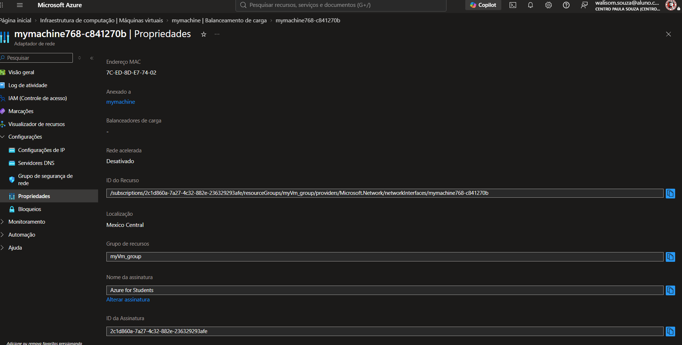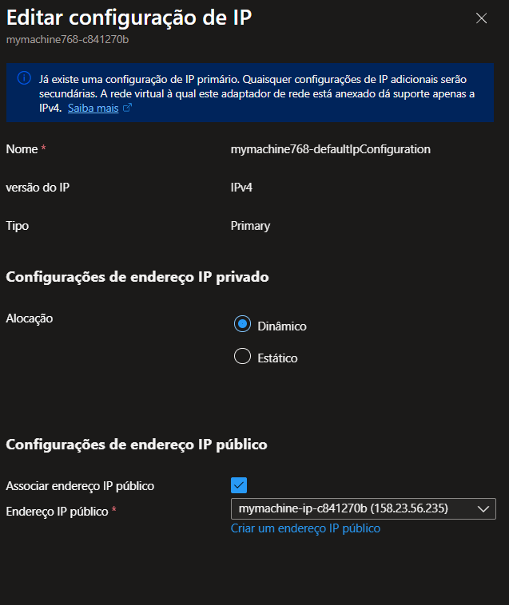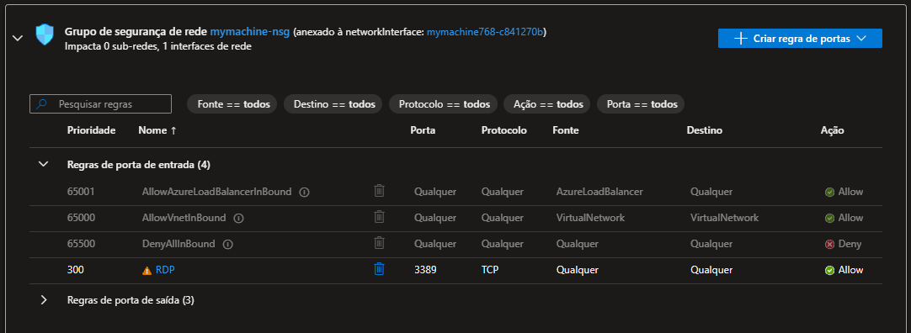

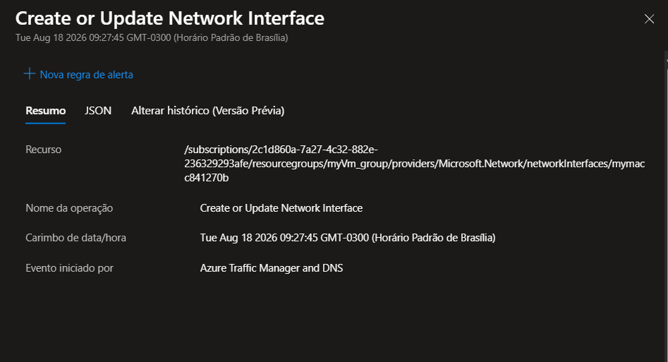

JSON rede virtual: {
"name": "Mymachine",
"id": "/subscriptions/2c1d860a-7a27-4c32-882e-236329293afe/resourceGroups/myVm_group/providers/Microsoft.Network/virtualNetworks/Mymachine",
"etag": "W/\"28decaf5-9d16-4244-9eb3-3d6b4ac9a836\"",
"type": "Microsoft.Network/virtualNetworks",
"location": "mexicocentral",
"tags": {},
"properties": {
"provisioningState": "Succeeded",
"resourceGuid": "64be5c19-5219-4a78-9bd0-112dbdef0f4f",
"addressSpace": {
"addressPrefixes": [
"10.0.0.0/16"
]
},
"encryption": {
"enabled": false,
"enforcement": "AllowUnencrypted"
},
"privateEndpointVNetPolicies": "Disabled",
"subnets": [
{
"name": "default",
"id": "/subscriptions/2c1d860a-7a27-4c32-882e-236329293afe/resourceGroups/myVm_group/providers/Microsoft.Network/virtualNetworks/Mymachine/subnets/default",
"etag": "W/\"28decaf5-9d16-4244-9eb3-3d6b4ac9a836\"",
"properties": {
"provisioningState": "Succeeded",
"addressPrefixes": [
"10.0.0.0/24"
],
"delegations": [],
"privateEndpointNetworkPolicies": "Disabled",
"privateLinkServiceNetworkPolicies": "Enabled",
"defaultOutboundAccess": false
},
"type": "Microsoft.Network/virtualNetworks/subnets"
}
],
"virtualNetworkPeerings": [],
"enableDdosProtection": false
}
}

